

**Distributed Computing**

Lab Assignment-1

WAQAS ASHIQ

BCS-F11-201

Submitted To:

Madam Humera Afzal

**Client side code:**

#include <sys/socket.h>

#include <sys/types.h>

#include <netinet/in.h>

#include <netdb.h>

#include <stdio.h>

#include <string.h>

#include <stdlib.h>

#include <unistd.h>

#include <errno.h>

#include <arpa/inet.h>

int main(int argc, char *argv[])

{

int sockfd = 0, n = 0;

char recvBuff[1024];

struct sockaddr_in serv_addr;

if(argc != 2)

{

printf("\n Usage: %s <ip of server> \n",argv[0]);

return 1;

}

memset(recvBuff, '0',sizeof(recvBuff));

if((sockfd = socket(AF_INET, SOCK_STREAM, 0)) < 0)

{

printf("\n Error : Could not create socket \n");

return 1;

}

memset(&serv_addr, '0', sizeof(serv_addr));

serv_addr.sin_family = AF_INET;

serv_addr.sin_port = htons(5000);

if(inet_pton(AF_INET, argv[1], &serv_addr.sin_addr)<=0)

{

printf("\n inet_pton error occured\n");

return 1;

}

if( connect(sockfd, (struct sockaddr *)&serv_addr, sizeof(serv_addr)) < 0)

{

printf("\n Error : Connect Failed \n");

return 1;

}

printf("Please enter the message: ");

bzero(recvBuff,1024);

fgets(recvBuff,1024,stdin);

n = write(sockfd,recvBuff,strlen(recvBuff));

bzero(recvBuff,1024);

n = read(sockfd,recvBuff,1024);

if (n < 0){

error("ERROR reading from socket");

}

printf("%s\n",recvBuff);

read(sockfd,recvBuff,1024);

close(sockfd);

return 0;

}

**Server side code:**

#include <sys/socket.h>

#include <netinet/in.h>

#include <arpa/inet.h>

#include <stdio.h>

#include <stdlib.h>

#include <unistd.h>

#include <errno.h>

#include <string.h>

#include <sys/types.h>

#include <time.h>

int main(int argc, char *argv[])

{

int listenfd = 0, connfd = 0,n=0;

struct sockaddr_in serv_addr;

char sendBuff[1025];

time_t ticks;

listenfd = socket(AF_INET, SOCK_STREAM, 0);

memset(&serv_addr, '0', sizeof(serv_addr));

memset(sendBuff, '0', sizeof(sendBuff));

serv_addr.sin_family = AF_INET;

serv_addr.sin_addr.s_addr = htonl(INADDR_ANY);

serv_addr.sin_port = htons(5000);

bind(listenfd, (struct sockaddr*)&serv_addr, sizeof(serv_addr));

listen(listenfd, 10);

while(1)

{

connfd = accept(listenfd, (struct sockaddr*)NULL, NULL);

bzero(sendBuff,1025);

n = read(connfd,sendBuff,1025);

if (n < 0){ error("ERROR reading from socket");}

printf("Here is the message: %s\n",sendBuff);

ticks = time(NULL);

snprintf(sendBuff, sizeof(sendBuff), "%.24s\r\n", ctime(&ticks));

write(connfd,"I got your message at this time: ",31);

write(connfd, sendBuff, strlen(sendBuff));

close(connfd);

sleep(1);

}

}

**Client Side output:**

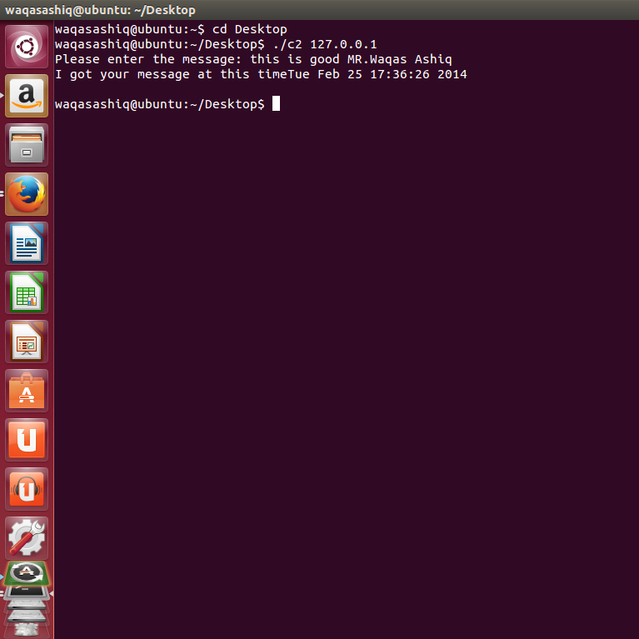

**Server Side output:**

